Download Participant Report from a Teams Meetings

Posted on [**June 12, 2020**](https://office365itpros.com/2020/06/12/download-participant-report-teams-meetings/) by [**Tony Redmond**](https://office365itpros.com/author/thoughtsofanidlemind/)

Know Who Attends a Teams Meeting

The ability for meeting organizers to download a participant report for a Teams meeting rolled out in May 2020 (Microsoft 365 [**roadmap item 63351**](https://www.microsoft.com/en-US/microsoft-365/roadmap?filters=&searchterms=63351)) and should now be available everywhere. The feature is supported in the Windows and Mac desktop clients (but not Linux) and the browser client. The feature is especially popular in education tenants where teachers need to record attendance rosters to note which students attend a class.

Meeting participant (or engagement) reports are disabled by default and need to be enabled by updating the *AllowEngagementReport*setting in Teams meeting policies. For example, to update the global (default) meeting policy to enable participant reports, run the command:

Set-CSTeamsMeetingPolicy -Identity Global -AllowEngagementReport "Enabled"

Downloading a Report

Once the meeting policy assigned to their account has been updated to enable participant reports, meeting organizers will see a download button in the meeting roster screen (Figure 1).

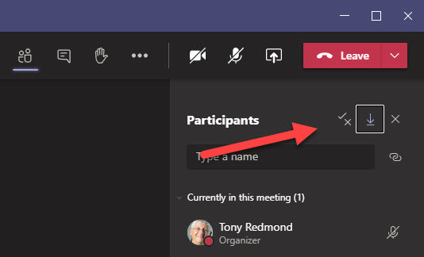Figure 1: Downloading a Teams Meeting Participant List

Clicking the button causes Teams to create and download a CSV file called *meetingAttendanceList.csv* containing participant data to the local workstation. Each record in the file has three fields:

* Full name (account display name).
* Activity (joined – or joined before a meeting starts, left)
* Timestamp.

An example record is shown below.

Tony Redmond Joined 6/9/2020, 4:58:45 PM

Michael James Joined before 6/9/2020, 4:58:45 PM

Jim Clark Joined before 6/9/2020, 4:58:45 PM

Jim Clark Left 6/9/2020, 4:58:57 PM

Jim Clark Joined 6/9/2020, 4:58:57 PM

You can open the file with Excel or process it with PowerShell, which might be used to extract data for inclusion in another repository.

Only Available During Active Meetings

It’s important to understand that the participant report is only available while the meeting is active with the participants still present. Once everyone leaves or the meeting is ended, the participant data disappears. If the meeting hasn’t ended and you rejoin it, the only participant information that’s available is the fact that you rejoined. For this reason, you must remember to download the report before you leave a meeting.

The need to grab a participant report when a meeting is active trip has tripped me up several times. It would be much better of Teams allowed more flexible capture of participant data. That might well come in the future.